TRIOLE for Service User Guide

April 1, 2009

Table of Contents

Logging into the System 3
Incident Notification 4
Searching for an Incident (Open or Closed) 5
Navigating the Incident Screen 6
Adding Comments to an Incident 7
Suspending a Ticket 8
Attaching a file 9
Transfer an Incident to another user/group 11
Resolve an Incident 12
Viewing the Response Time and SLA on an Incident 14
Priority and SLA Matrix 15
Modifying Contact Information - Notification Method (Pager or Email) 16
Incident Color Scheme definition 18
Status definitions 19
Email Notifications 20
Creating a Service Request 28
Closing a Service Request 29
Creating a Change Order From an Incident 30

Logging into the System

What is the URL?
https://trioleservicedesk.fai.fujitsu.com/CAisd/pdmweb.exe

What is my username and password
Username = FAI.FirstName.LastName
Password = Will be mailed to you.

Incident Notification

When an incident has been assigned to either you or a group you are a member of an automated email will be generated. From this email you’ll be able to determine the affected end user, the priority, and the initial description of the issue.

The incident # in this email is a hyperlink to the ticket. If you click the link your browser will launch and you’ll be prompted to login to TfS. Once logged in, you’ll be re-directed to the ticket.

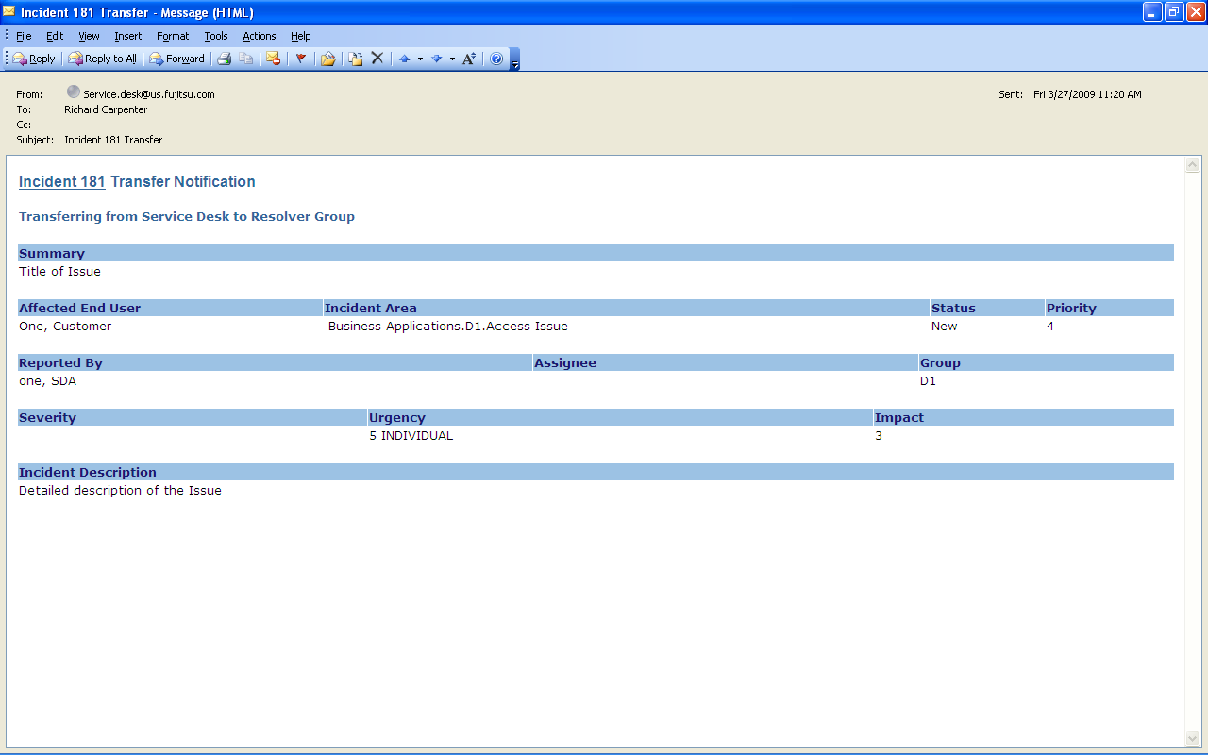

Searching for an Incident (Open or Closed)

Quick Search
The Quick search function is located in upper right hand corner of the Service Desk’s “main screen”.
This feature allows users to search from a category in the drop down menu to perform a quick search if the category number is known.
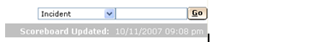

Advanced Search
Provides searching capabilities for all types of records; Incidents, Problems, Change Orders, CIs, Contacts, etc. This is a more intuitive search that allows the user to limit search results to a very concise set based on the search criteria. To search for Closed Incidents, choose inactive for the Active type. Remember the group will be Service Desk for all of these.
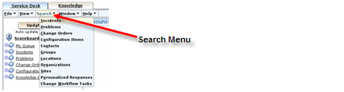

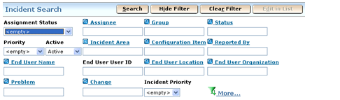
The display for searching an incident is shown in the above print screen. Users have the ability to search many different fields: Assignee, Group, Status, Priority, state, Incident Area, Configuration Item, Reported By, etc ….
- Using the icon provides additional fields to search.
- Selecting any of the fields displayed as a hyperlink will allow users to view the data and select, to enter the search criteria.

Navigating the Incident Screen

From within the incident screen you’ll have access to:
- Affected End User
- Reported By
- Classification – This is the coding for the ticket. It was category, sub-category, product, and problem type in Service Center.
- Urgency
- No. of Users Affected by Issue
- Summary and Description
- Activity log – This tab contains the audit log for the ticket
- Properties – Properties can be tied to classification. They are used to ask questions about a certain category set. None have been loaded yet, but we expect to use them soon.
- Attachments

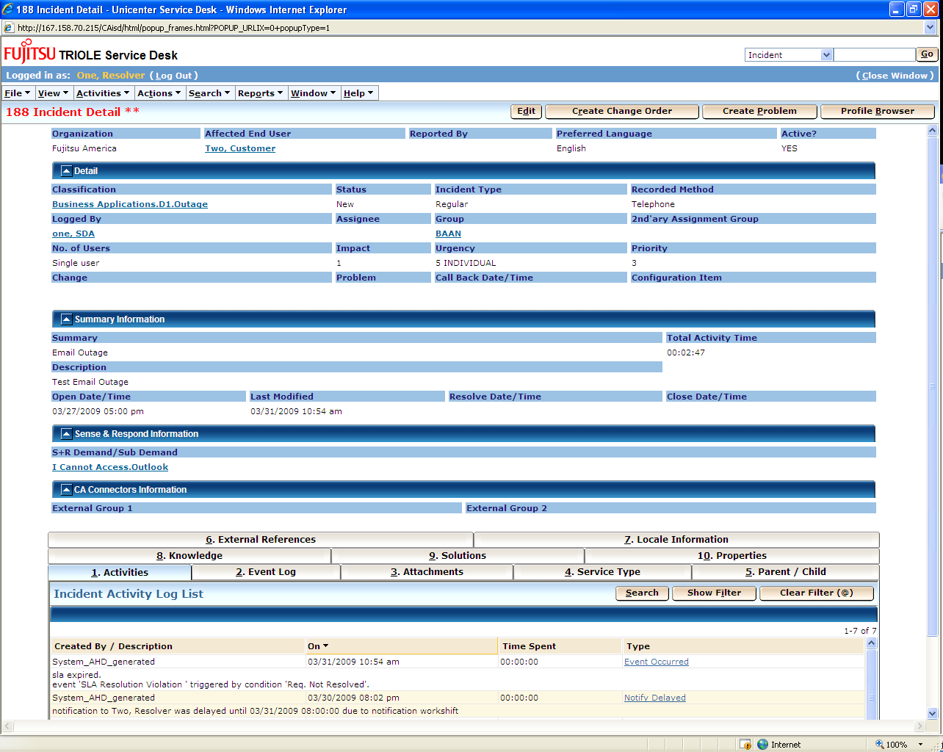

Adding Comments to an Incident

Within the incident window click the “Activities” menu and select “Log Comment”

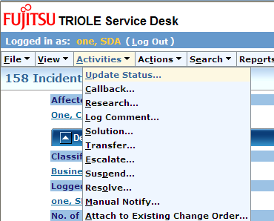

This will cause the following activity window to appear

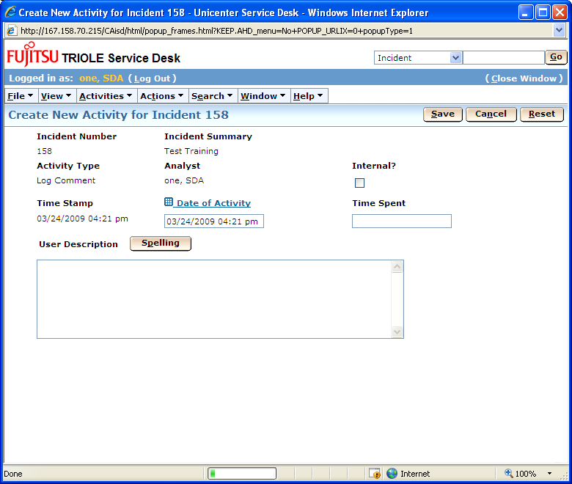

You may enter your update in the “User Description” field. Please note that any update with the “Internal” flag ticked will not be visible to the user community.

Click the “Save” button once you are finished with the update. This will cause the window to close and log your update under the “Activities” tab.

Suspending a Ticket

Within the incident window click the “Activities” menu and select “Log Comment”

This will cause the following activity window to appear. You can enter the time you would like the ticket to resume. You will also need to enter the reason for the delay.

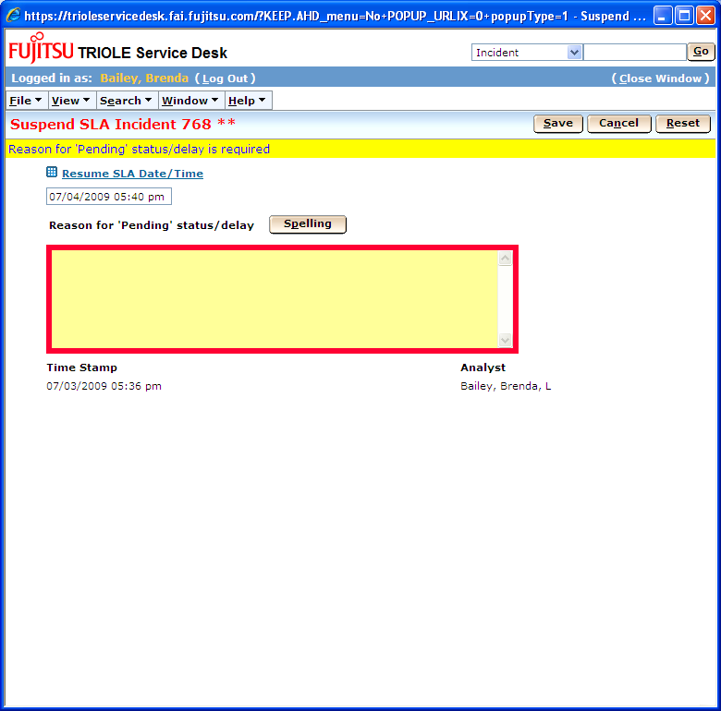
Attaching a file

Go to Tab 3 Attachments and choose the Attach Document Button

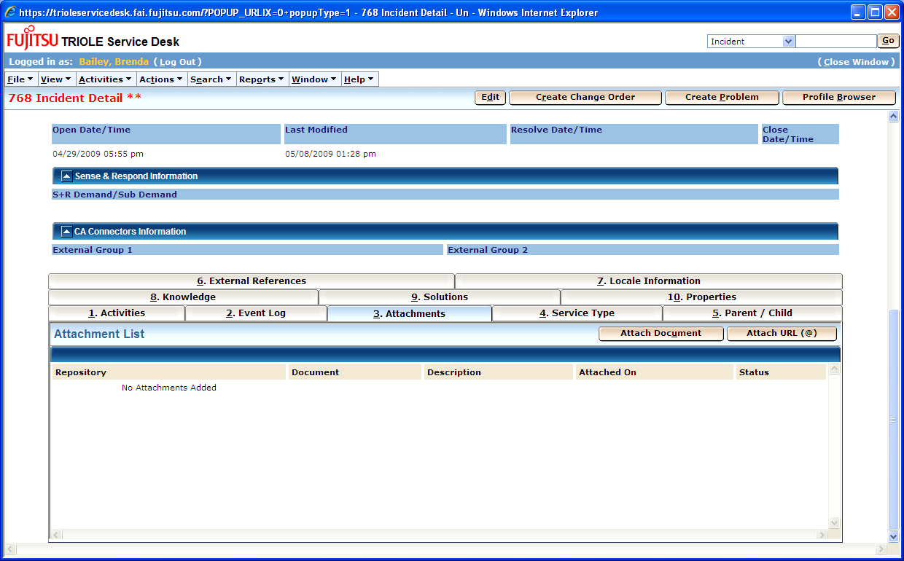

Click on the Browse Button and chose the file to upload. Choose FAI SD Repository for the Repository Name. Click the Upload Button.

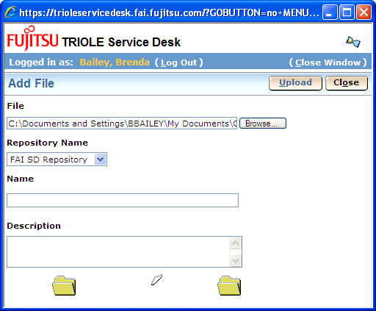

When the security Information Box displays, click yes. It will then upload the file.

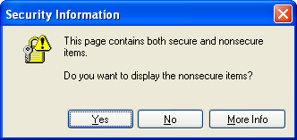

The following box will display when the file is successfully uploaded.

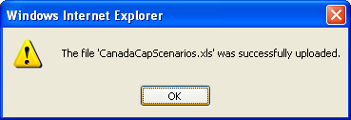

Transfer an Incident to another user/group

Within the incident window click the “Activities” menu and select “Transfer”

This will cause the following activity window to appear

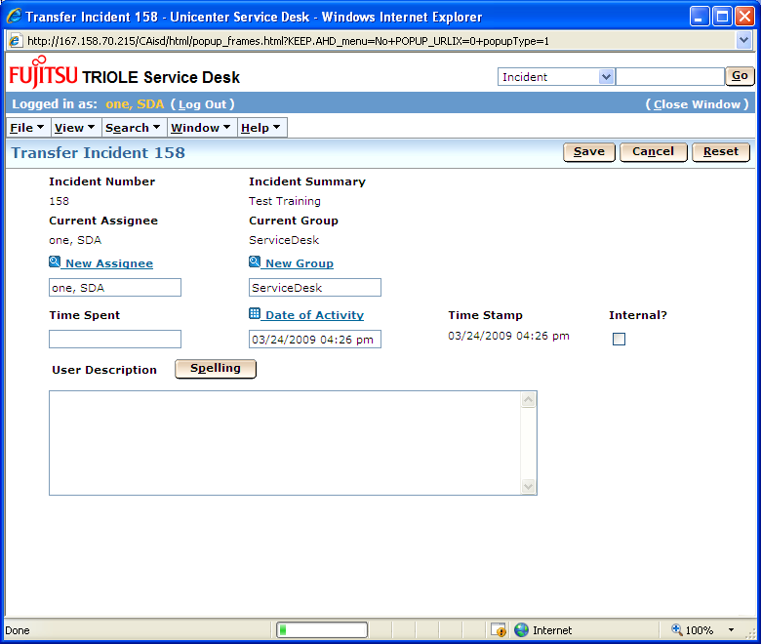

You may populate the “New Group” field by:
- Clicking the “New Group” hyperlink and select the new group from the list. Make sure the group you chose is prefixed with FAI. Do not use AEM groups.
- Deleting the current value and typing in the name of the new resolver group. Once the new value has been entered click the “New Group” hyperlink to validate the data.
NOTE: You may use wildcards “%”

Click the “Save” button once you are finished with the update. This will cause the window to close and log your update under the “Activities” tab.

Resolve an Incident

Within the incident window click the “Activities” menu and select “Resolve”

This will cause the following activity window to appear

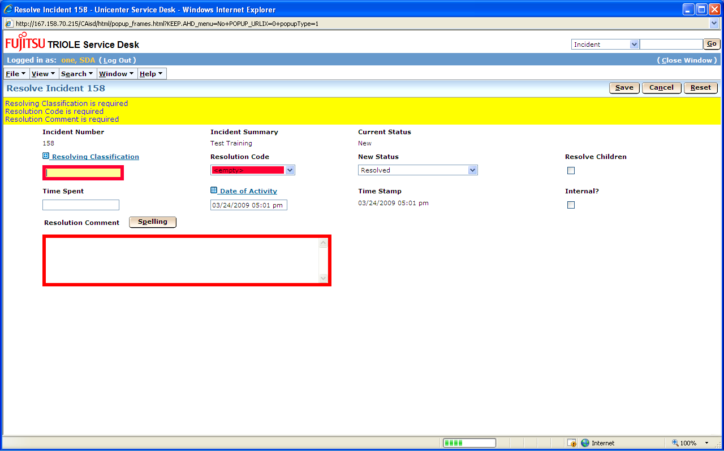

The following fields are mandatory:
- Resolution Classification: I believe this field should pull from the incident classification; we’re working to see if this can be corrected. Until further notice you may copy/paste the classification from the incident. This should only be altered if through troubleshooting you discover the incident classification was incorrect.
- Resolution Code: Pick from the list the code that most accurately matches the resolution of the issue.

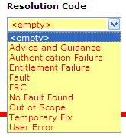

- Resolution Comment: Document any troubleshooting steps you took to resolve the issue. If all of your comments have been logged in the initial description you may copy/paste them to this field.
- New Status: This field can be set to:
  - Resolved:
  - Resolved with Customer:

NOTE: All calls must be resolved prior to closure.
NOTE: The purpose of the resolution is to allow resolver groups to state that they feel the issue has been resolved. This can happen with or without end user interaction.

Viewing the Response Time and SLA on an Incident

Go to Tab 4 Service Types.
The first line where it displays “120 Min cr Callback(Reg)” is the response time. SLA Warning is an alert that will send a notification when 80% of the SLA Time has been met. The SLA Violation is when the SLA expires. The expiration time column display the times for these notifications. The times are based on end-user locations.

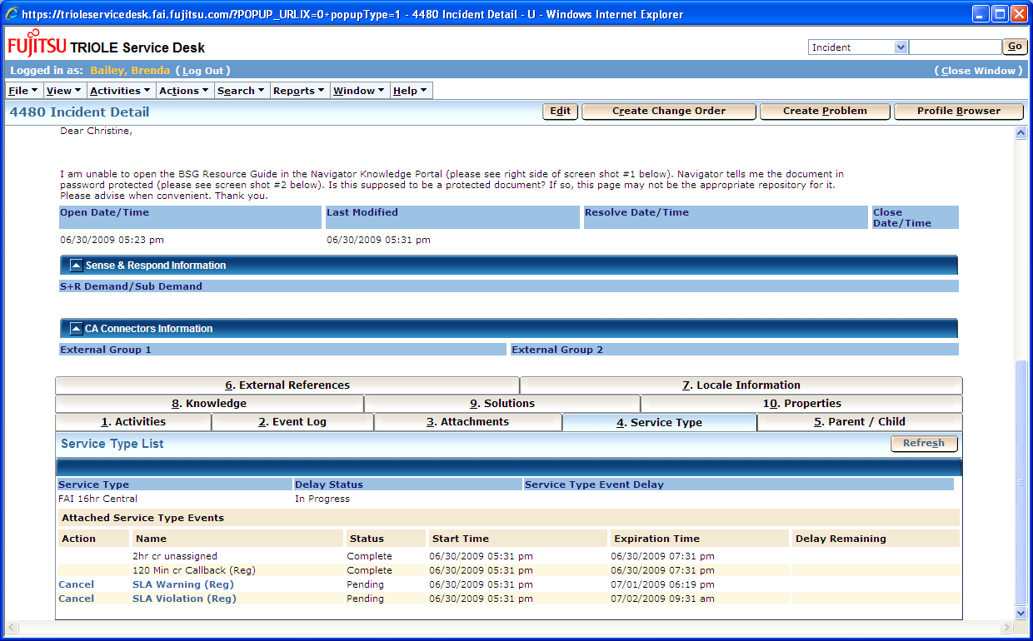
Priority and SLA Matrix
IMPACT
Criticality | Number of users affected
Criticality | > 70% | 40% - 70% | 10% - 40% | < 10% | Single user
1 – Critical Function | 1 | 1 | 1 | 1 | 1
2 – High Impact Function | 1 | 1 | 2 | 2 | 2
3 – Medium Impact Function | 2 | 2 | 3 | 3 | 3
4 – Low Impact Function | 3 | 3 | 4 | 4 | 4
5 – Cosmetic Function or Training System | 5 | 5 | 5 | 5 | 5

The Priority for allocating resource to the resolution of the incident is then based on a combination of impact and urgency, as per the table below:

PRIORITY
Impact | Urgency
Impact | 1 | 2 | 3 | 4 | 5
1 | 1 | 1 | 2 | 2 | 3
2 | 1 | 2 | 2 | 3 | 4
3 | 2 | 3 | 3 | 4 | 4
4 | 3 | 3 | 4 | 4 | 5
5 | 4 | 5 | 5 | 5 | 5

FAI Incident Resolution Service Levels
Business Hours are 7AM to 7PM local time. Local Time is based on end-user location. Default
Time will be CST. For example, any remote users will be CST.

Priority | Response | Resolution | Hours
Priority 1 | 30 minutes | 4 hrs | 24 x 7
Priority 2 | 4 hrs | 8 | Business Hours
Priority 3 | 8 hrs | 24 | Business Hours
Priority 4 | 16 hrs | 32 | Business Hours
Priority 5 | 48 hrs | 48 | Business Hours

Modifying Contact Information - Notification Method (Pager or Email)

On the front screen, under the View Tab, go to View the Profile Browser.

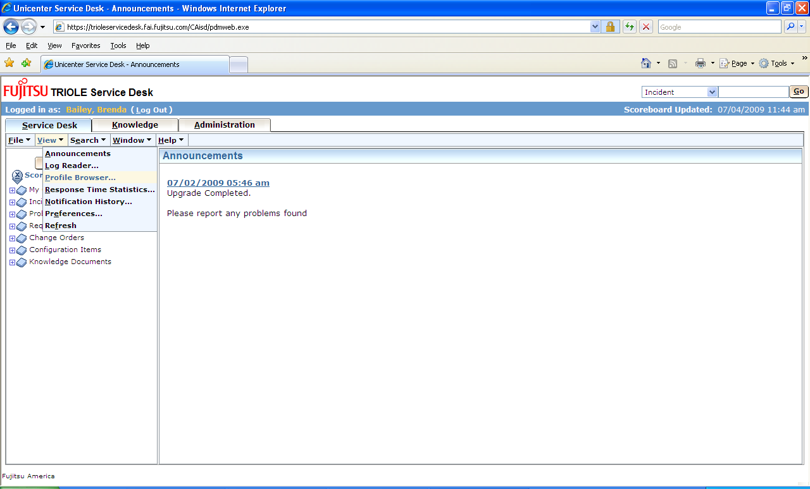

The contact search page will pop up. Key in your name, it will then display your contact information

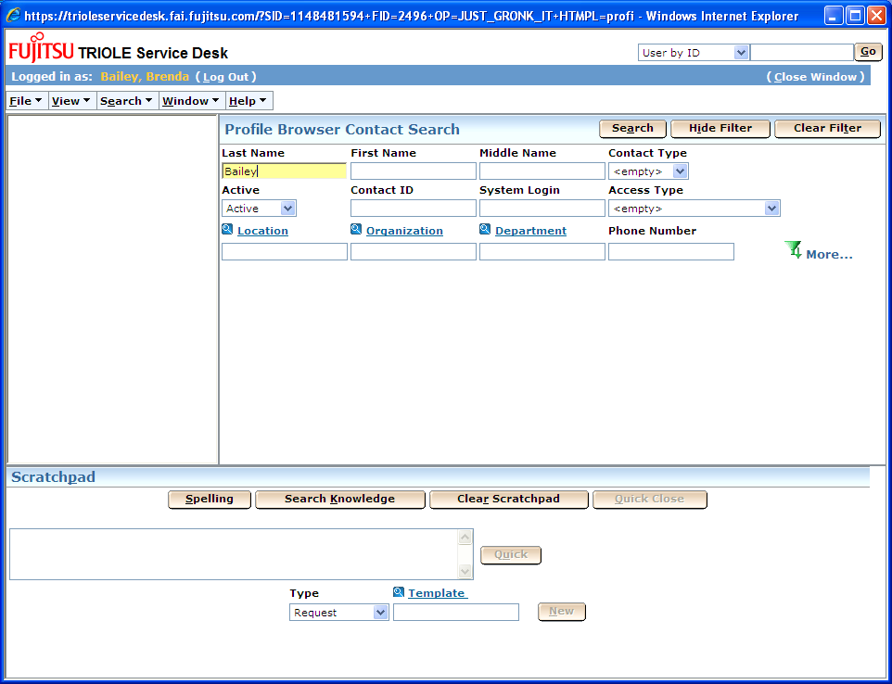

One the right hand side, Click the Edit this Contact button..
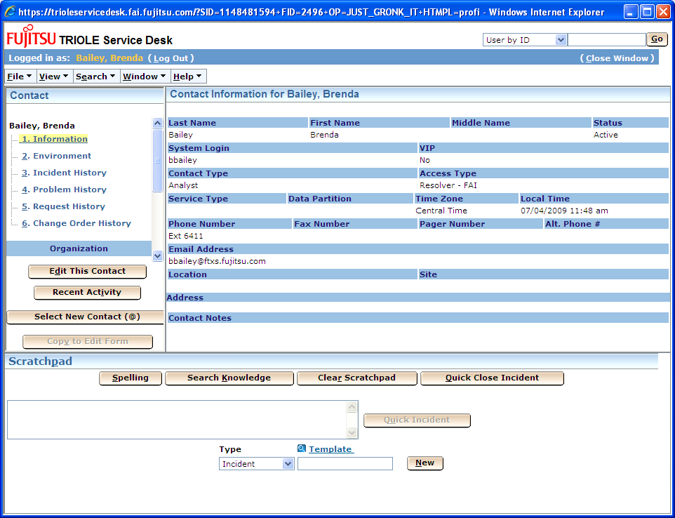

Go to Tab 1 called Notifications. For each type of notification, Low, Normal, High, Emergency, you can set either email or pager_email method. You will have your email in the email address field and your pager number would be entered in the Pager Email Address Field. The notifications for Open, Resolved and SLA’s are normal notifications. (Need to confirm) This will be changing.
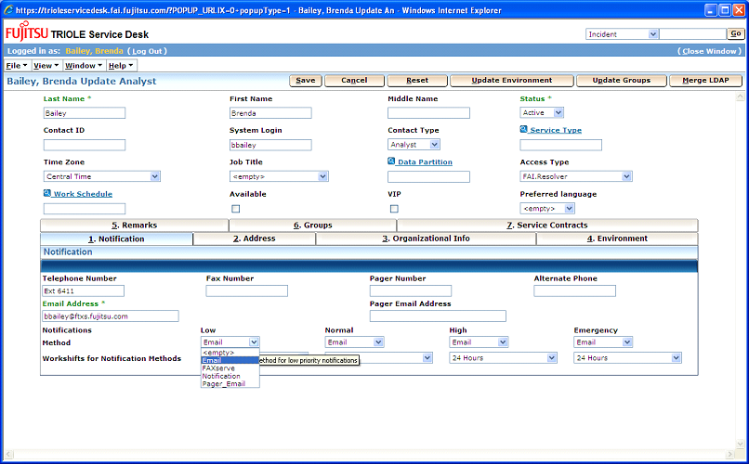

Incident Color Scheme definition

Amber – Identifies incidents that have missed the SLA Response Times
Red – Identifies incidents that have missed the SLA Resolution Times
Higlighted Red – Identifies a Major Incident

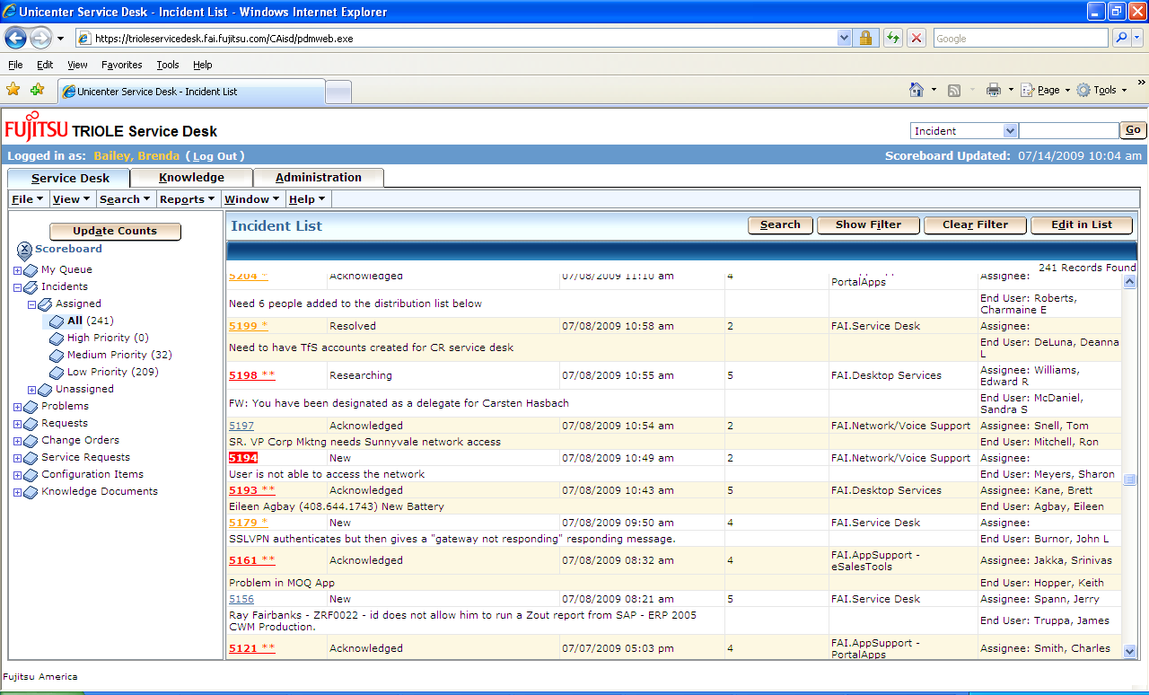

Status definitions

Incident Status
New – new incident created
Acknowledge – when ticket is acknowledge, it will be used as response time.
Work in Progress – this is what is normally used when working an issue

The following two statuses are for more detail in identifying the time for research compared to once the issue is known how long the fix will take. We do not need to use at this time.

Fix in Progress – know what problem is and are fixing
Researching – researching issue

Activities
Status Update – see above Incident Status
Callback – not used today
Research – not used today
Log Comment – logging of comments
Solution – not used today
Transfer – to transfer ticket to another group and/or un-assign
Escalate – not used today
Resolved – resolved without talking with customer. Service Desk will contact end user to confirm resolution.
Resolved with Customer – incident was resolved with the customer. These will automatically be close without Service Desk confirming resolution.

Incident Resolution Codes
Advice and guidance – provided the user advice and guidance
Authentication Failure – Failure on connection
Entitlement Failure – were not able to validate entitlement (this should never be used)
Fault – fault found and corrected
FRC - Not needed
No fault found – resolved with no fault found
Out of scope -
Temporary Fix – temporary work around
User Error – User caused error

Email Notifications

Open Incident Email
Notification: Affected End User
From: triole_servicedesk@us.fujitsu.com [mailto:triole_servicedesk@us.fujitsu.com]
Sent: Thursday, June 25, 2009 5:21 PM
To: Brenda Bailey
Subject: Incident 4103 New

Dear Sir/Madam,
Thank you for contacting the Servicedesk. Your incident has been logged and is being passed to the appropriate support group.
Incident 4103 New
Open Notification

Summary
TEST 8 HR

Affected End User | Incident Area | Status | Priority
Bailey, Brenda | FAI.Business Applications.TRIOLE | New | 2

Reported By | Assignee | Group
Bailey, Brenda L |  | TRIOLE

No. of Users | Urgency | Impact
10% to 40% of user base | 5 INDIVIDUAL | None

Incident Description
TEST 8HR SLA

Initial Ticket Open Notifications
Nofications: Group
From: triole_servicedesk@us.fujitsu.com [mailto:triole_servicedesk@us.fujitsu.com]
Sent: Thursday, June 25, 2009 5:21 PM
To: Brenda Bailey
Subject: Incident 4103 Initial

Incident 4103 Initial Notification
create a new request/incident/problem/change/issue

Summary
TEST 8 HR

Affected End User | Incident Area | Status | Priority
Bailey, Brenda | FAI.Business Applications.TRIOLE | New | 2

Reported By | Assignee | Group
Bailey, Brenda L |  | TRIOLE

Severity | Urgency | Impact
 | 5 INDIVIDUAL | None

Incident Description
TEST 8HR SLA

`

Transfer of Ticket Email

Notification: Group – Need to change this to assignee

From: FAI_Servicedesk@us.fujitsu.com [mailto:FAI_Servicedesk@us.fujitsu.com]
Sent: Tuesday, June 30, 2009 12:54 PM
To: Brenda Bailey
Subject: Incident 4095 Transfer

Incident 4095 Transfer Notification
This is an issue with the CAP Reprot on ServiceNet. It is not an EDI issue.

Summary
EDI issue, Not Receiving files from Expresspoint

Affected End User | Incident Area | Status | Priority
Kennon, Kevin | FAI.Business Applications.D1.Performance | Acknowledged | 3

Reported By | Assignee | Group
Smith, LaClise | Stratman, Ross | D1

Severity | Urgency | Impact
 | 5 INDIVIDUAL | 1

Incident Description
Not Receiveing files from expresspoint example of the issue see
attachment ServiceNet and ExpressNet should match

Resolution of Ticket

Notifications: Affected End User

From: FAI_Servicedesk@us.fujitsu.com [mailto:FAI_Servicedesk@us.fujitsu.com]
Sent: Wednesday, July 01, 2009 9:14 AM
To: Brenda Bailey
Subject: Incident 4217 Resolved

Dear Sir/Madam,
Following the investigations and activities of our support team(s) your incident has been resolved. Unless we hear otherwise within 24 hours your incident will be closed. If you believe that it has not been resolved, or you are not satisfied with the resolution, then please telephone the Servicedesk at 1-877-817-4357 and refer to the above reference number.
Incident 4217 Resolved
Resolution Notification

Summary
test 24 x 7 SLA

Affected End User | Incident Area | Status | Priority
Bailey, Brenda | FAI.Business Applications.TRIOLE | Resolved | 1

Reported By | Assignee | Group
Bailey, Brenda L |  | Service Desk

No. of Users | Urgency | Impact
10% to 40% of user base | 5 INDIVIDUAL | None

Incident Description
TEST 24 x 7 VIOLATION - CHANGE ME TO MANAGER, I should get un-assigned alerts and SLA 80% and SLA missed.

Missed Response Time (This one will be changing soon )

Notifications: Group Manager

Original Message-----
From: triole_servicedesk@us.fujitsu.com [mailto:triole_servicedesk@us.fujitsu.com]
Sent: Wednesday, July 08, 2009 11:52 AM
To: Brenda Bailey
Subject: 'Req. Status = New' event notify assignee for request '5199'

request 5199 event notification
priority: 2
assigned to: Bailey, Brenda
customer: DeLuna, Deanna L
description: Need to have TfS accounts created for the following users.
Erick Fernandez
Jose Otárola
David Vargas
Cesar Castillo
Arturo Castillo
Failan Artavia
Diego Mora
Leonardo Barboza
Johhny Segura
Mauricio Rojas
Luis Diego Mata
Roberto Morera
Giancarlo Zuñiga
Eduardo Flores

80%Warning on SLA Violation

Notifications: Assignee
Group Manager

-----Original Message-----
From: triole_servicedesk@us.fujitsu.com [mailto:triole_servicedesk@us.fujitsu.com]
Sent: Friday, June 26, 2009 6:50 PM
To: Brenda Bailey
Subject: 'Req. Not Resolved' event notify assignee for request '3927' - need this to say "SLA 80% Warning"

request 3927 event notification
priority: 5
assigned to: Bailey, Brenda
customer: Dolph, Lorna J
description: Tyler Rowe 972-479-2588 Need to have the Desktop Group added to the FTXS domain. Names are as follows:

Ben Copeland
Jeff Shelton
Giac Nguyen
Orville Riaggo
Robert Dattoli

SLA Violation

Notifications: Group Manager

-----Original Message-----
From: triole_servicedesk@us.fujitsu.com [mailto:triole_servicedesk@us.fujitsu.com]
Sent: Monday, June 29, 2009 4:26 PM
To: Brenda Bailey
Subject: 'Req. Not Resolved' event notify assignee for request '3927'

request 3927 event notification
priority: 5
assigned to: Bailey, Brenda
customer: Dolph, Lorna J
description: Tyler Rowe 972-479-2588 Need to have the Desktop Group added to the FTXS domain. Names are as follows:

Ben Copeland
Jeff Shelton
Giac Nguyen
Orville Riaggo
Robert Dattoli

Creating a Service Request

On the front screen, under the File Tab, choose New Change Order.

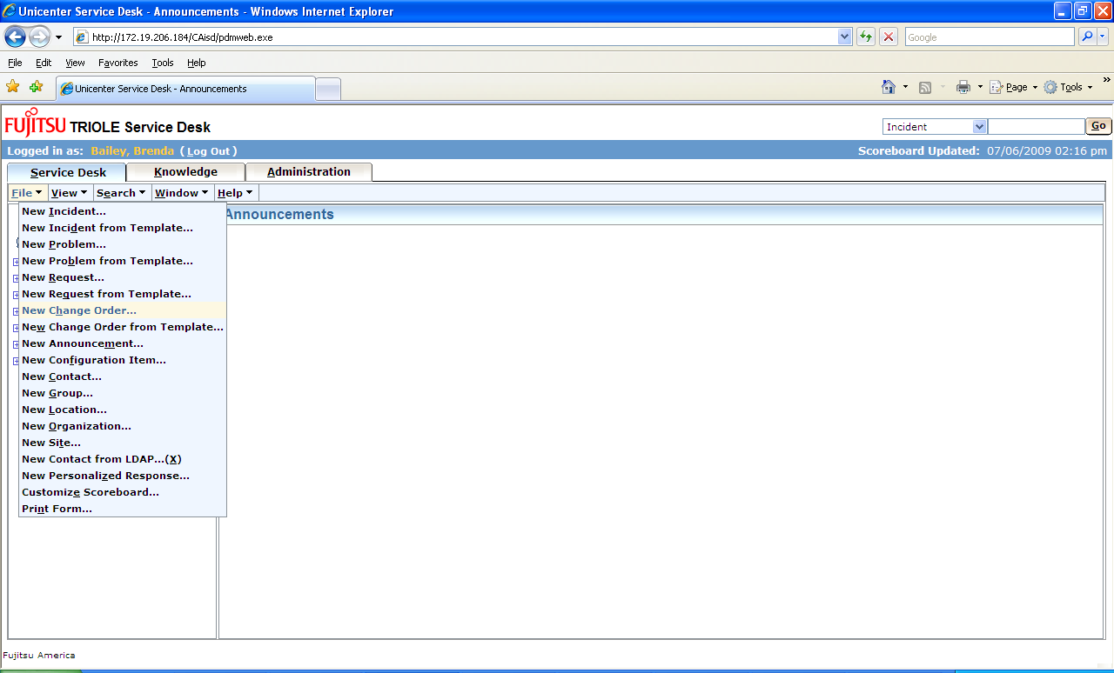

When choosing the classification on the next screen, choose a service request classification.

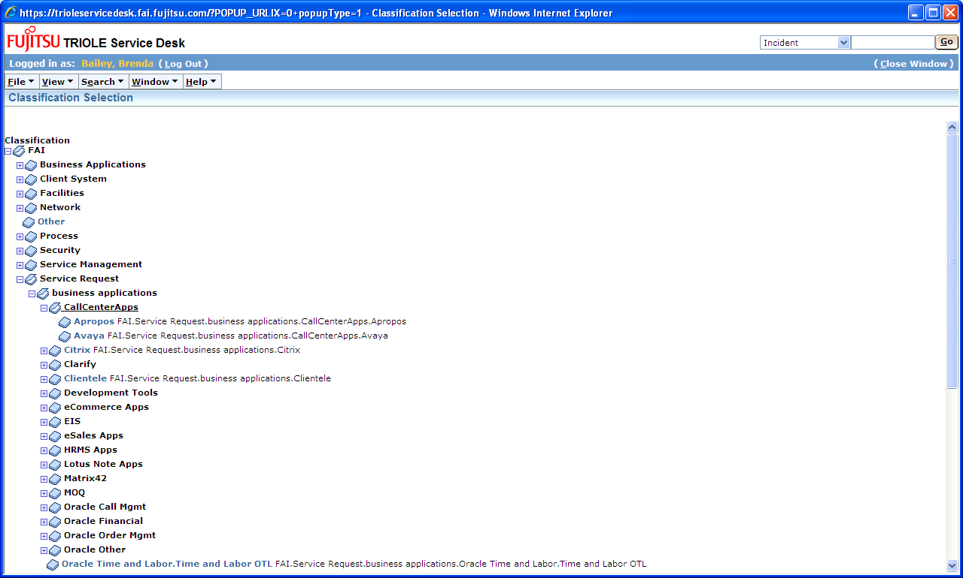
From within the Change Order screen you’ll have access to:
- Requestor
- Affected End User
- Classification – You will need to choose the classification that is for Service Request (see screen shot on next page). It will be display as FAI.ServiceRequest.XXXX. This is the coding for the ticket. It was category, sub-category, product, and problem type in Service Center.
- Priority – Normal, Expedited, Emergency
- Risk/Impact – Low, Medium, High
- Need By Date
- Order Summary
- Order Description
- Workflow Tasks
- Activity log – This tab contains the audit log for the ticket
- Attachments

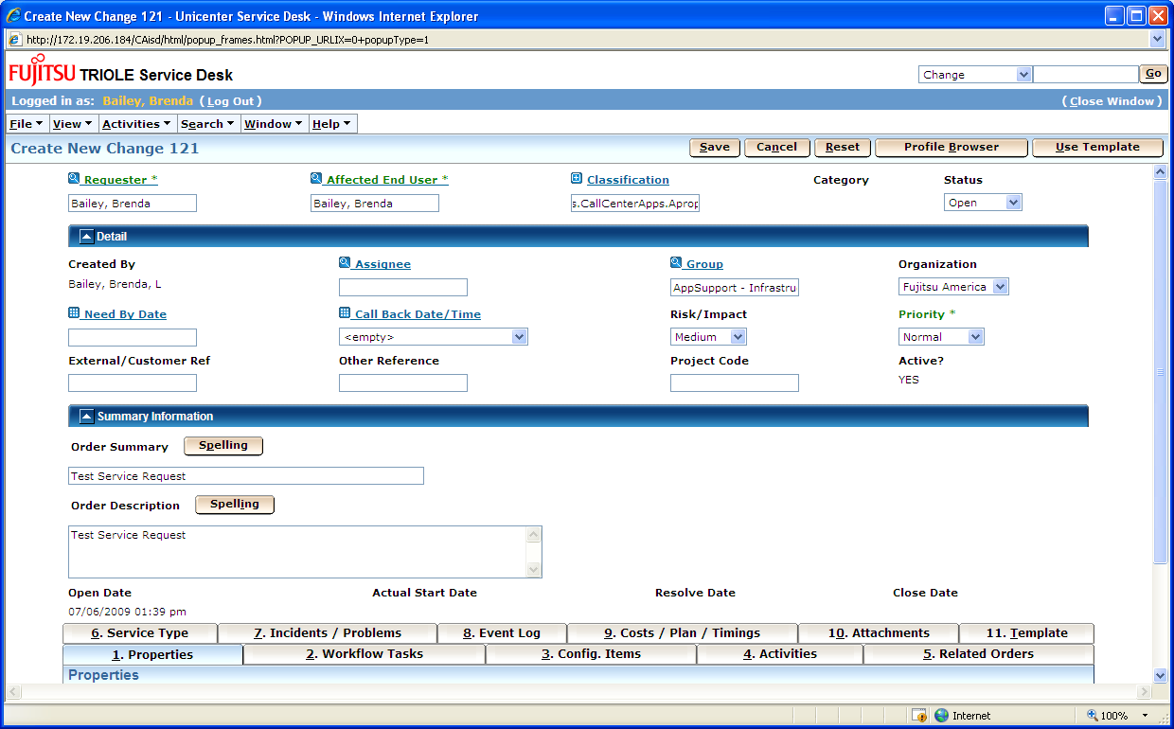

Closing a Service Request
To process a Service Request, you will need to complete the workflow tasks.

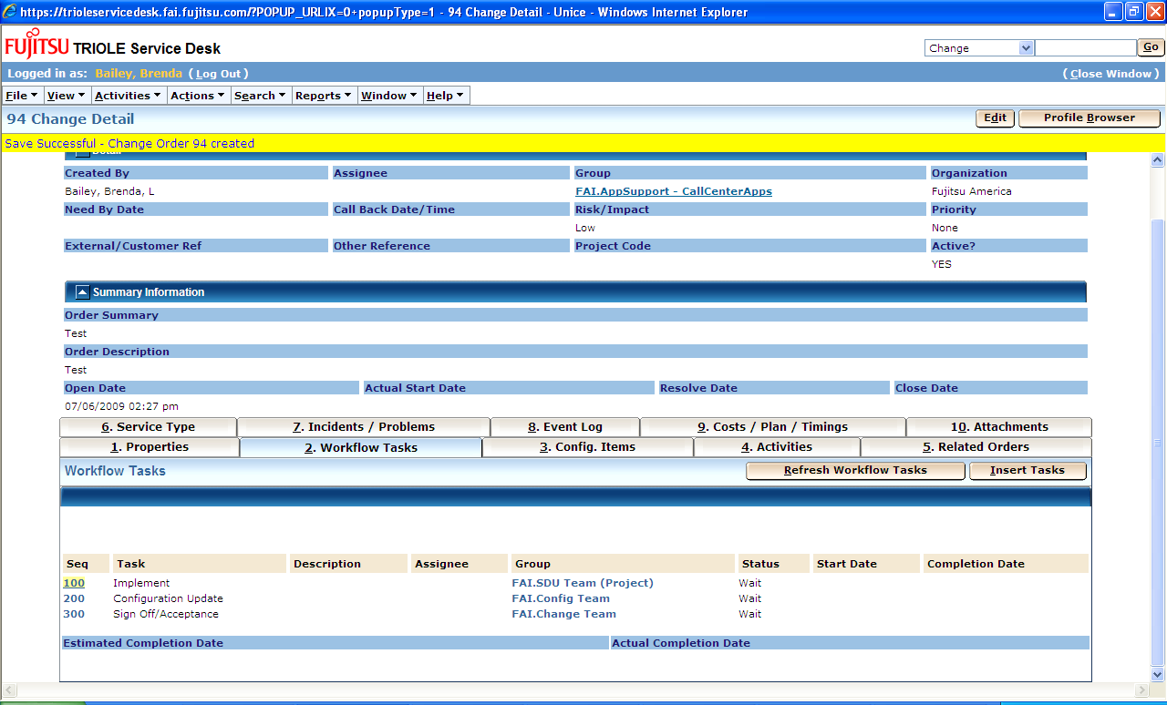

Click on Seq 100, it will pop up another screen, please choose the edit button in the right hand corner of the screen. This will allow you to update the status to complete. You will need to do the same for Seq 200.

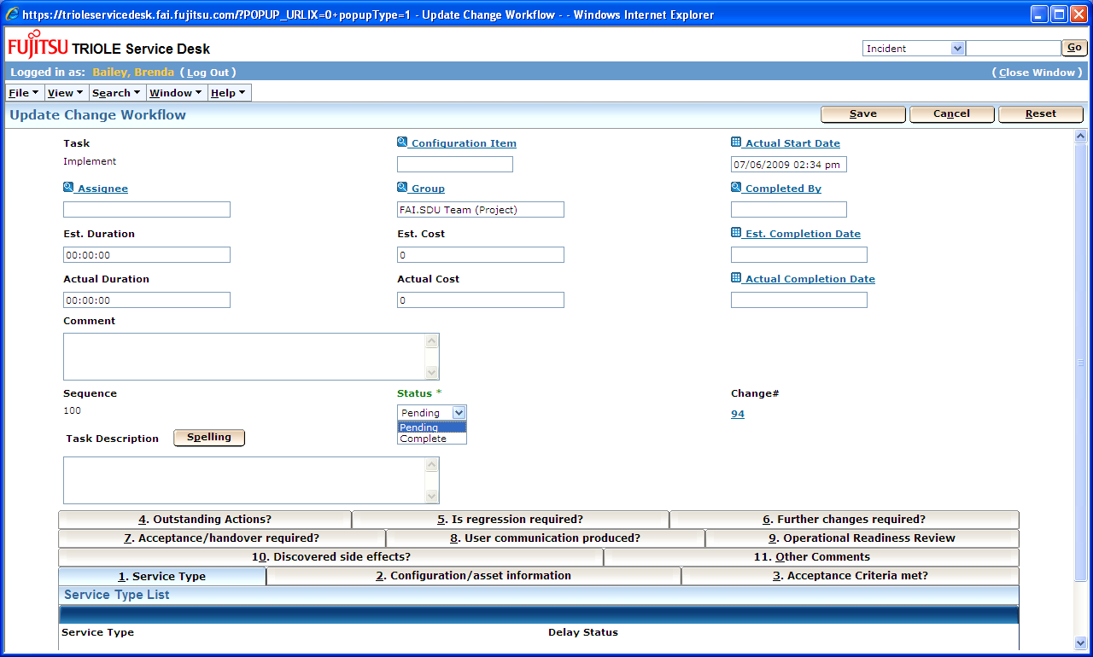

On Seq 300, you will have the option to close the ticket with 3 different statuses:
Closed –Successful – This will close out the service request
Closed – Failed – This will put the service request in a closed-failed status
Closed - Regression – This will put the service request in closed – regressed status

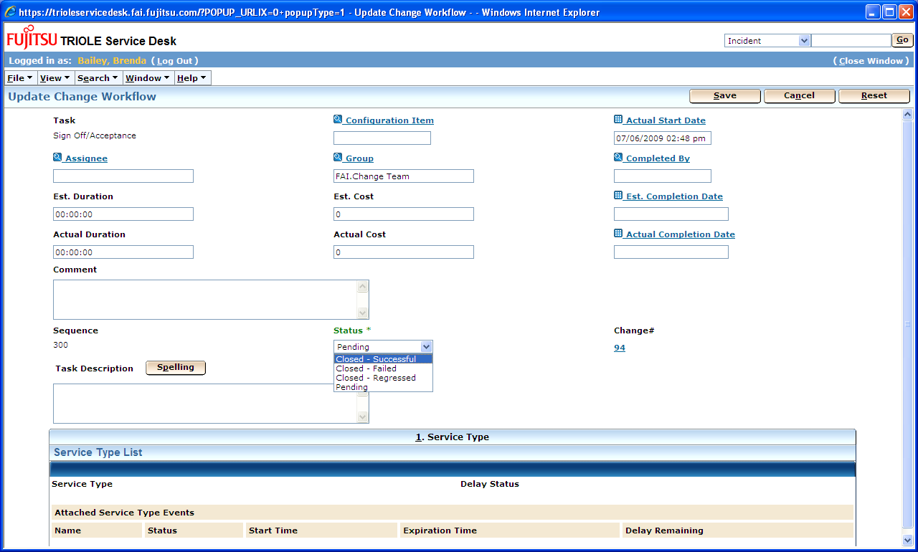

FAI Service Request Resolution Service Levels
Business Hours are 7AM to 7PM local time. Local Time is based on end-user location. Default
Time will be CST. For example, any remote users will be CST.

Priority | Response | Resolution | Hours
Priority 1 | 4 hours(emergency) | 1 Business Day | Business Hours
Priority 2 | 1 Business day(Expedited) | 3 Business Day | Business Hours
Priority 3 | 1 Business Day(Normal) | 5 Business Day | Business Hours
Priority 4 | N/A | N/A | Business Hours
Priority 5 | N/A | N/A | Business Hours

Creating a Change Order from an Incident

Click on the Create Change Order button, it will copy information from the incident to the Service Request. The Service Request Classification will need to be chosen as described within the Service Request documentation.

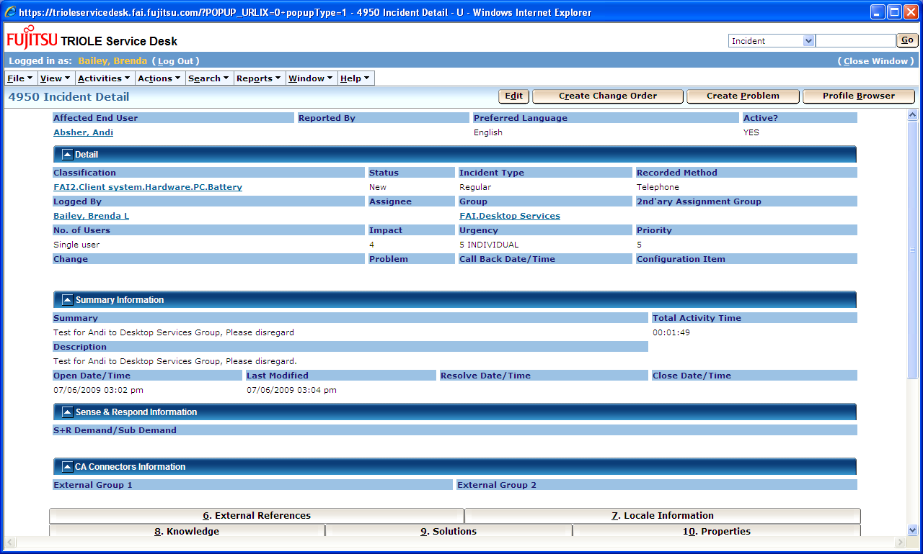
New Change Order created from Service Request above. The incident type, impact, urgency, no. of users, summary and descriptions were all copied from the incident.

